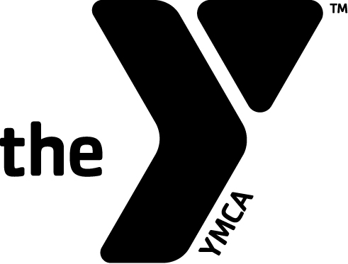

Christian County YMCA
2020/2021 Youth Sport League Sponsorship Form

Sponsor/Business Name:_______________________

Contact Person:______________________________

__Yes, I would like to sponsor a YMCA Youth Team:
$225/season, $400 for 2 seasons, $550 for 3 seasons

____Fall Soccer Sponsor
____Basketball Sponsor
____Spring Soccer Sponsor

____Please bill me closer to the season(s).

I prefer to Sponsor: ( Age and League)

_____________-Shirt Color

_____________-Ink Color

____Enclosed is a new logo.

____Use the same logo as last year..

____No, I am unable to sponsor this year.

