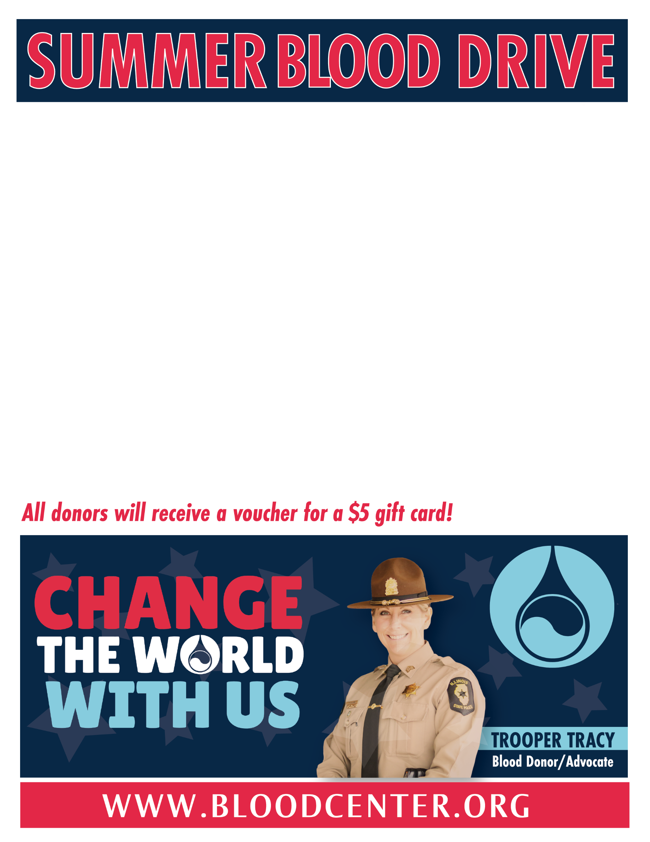

**Taylorville Community**

**Tuesday, June 30th 10:00 am – 1:00 pm**

**Christian County YMCA - Bloodmobile** *(900 McAdam Dr.)*

To donate, call the Blood Center at (217) 241-7550 or visit [www.bloodcenter.org](http://www.bloodcenterimpact.org) (using group code 60145).

***All donors must have an appointment and wear a mask!***

*Please eat before donating and bring Photo ID.*

Last Date to Donate Elsewhere: 05/05/20